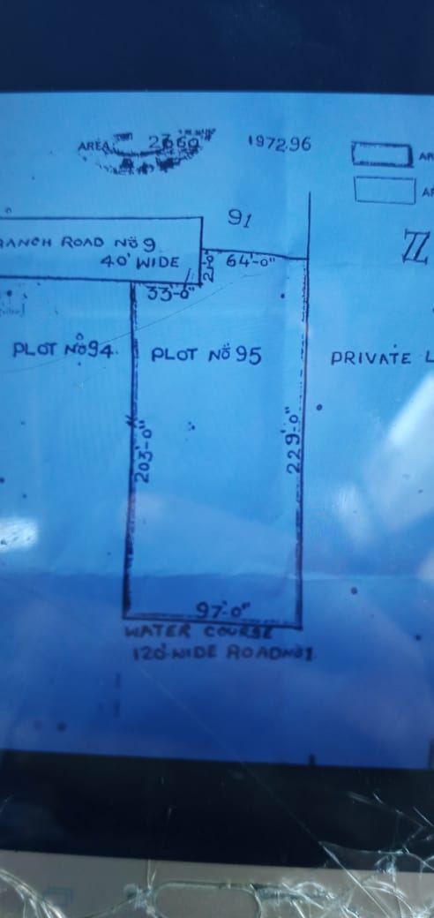

Owner Details : 9885192929 (Advocate)

Facing : East West (2 side roads)

Land Mark : Beside TV5 Office, Opp to Chiranjeevi Blood Bank

Rate : 3 L, Negotiable

Dimensions : 2363 Sq Yards